**Experiment No:** 14

**Experiment name:**  FCFS Disk Scheduling Algorithm

**Advantages:**

i.This algorithm is very simple to implement.

ii.The aging technique is implemented to reduce the starvation.

**Source Code:**

#include<stdio.h>

void main()

{

int queue[20],n,head,i,j,k,seek=0,max,diff;

float aver;

printf("enter the max range of disk: \n");

scanf("%d",&max);

printf("enter the size of queue request: \n");

scanf("%d",&n);

printf("enter the queue: \n");

for(i=1; i<=n; i++)

{

scanf("%d",&queue[i]);

}

printf("enter the initial head position: \n");

scanf("%d",&head);

queue[0]=head;

for(j=0; j<=n-1; j++)

{

diff=abs(queue[j+1]-queue[j]);

seek+=diff;

printf("move is from %d to %d with seek: %d\n",queue[j],queue[j+1],diff);

}

printf("total seek time is: %d\n",seek);

aver=seek/(float)n;

printf("avrage seek time is: %f\n",aver);

getch();

}

**Result:**

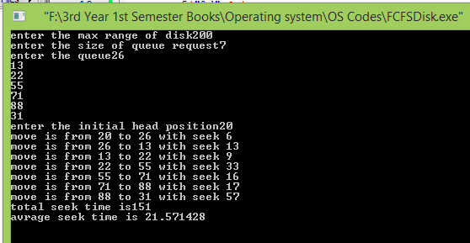

**Conclusion:**

This type of scheduling is one of the very basic algorithm for operating systems in computer which can be implemented through circular queue data structure. Our honorable teacher helped us by giving some important lecture which helped us to code these above method.